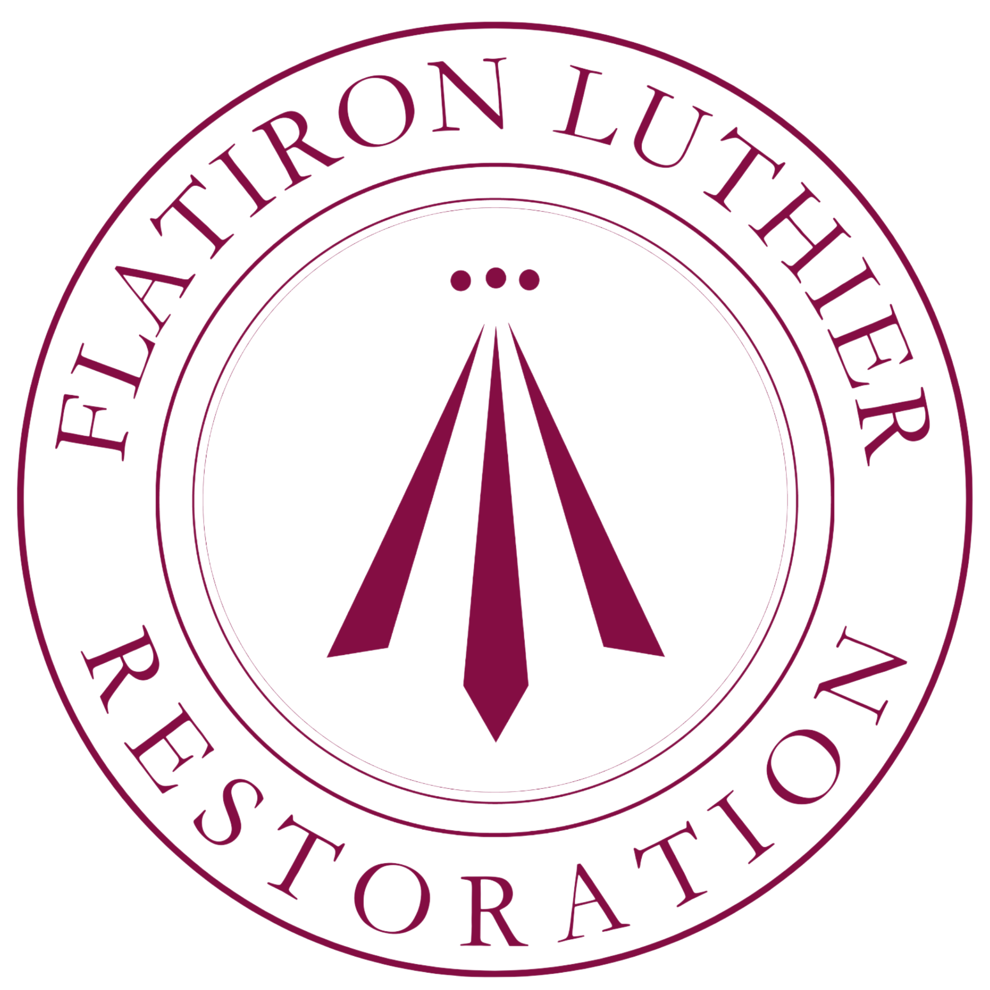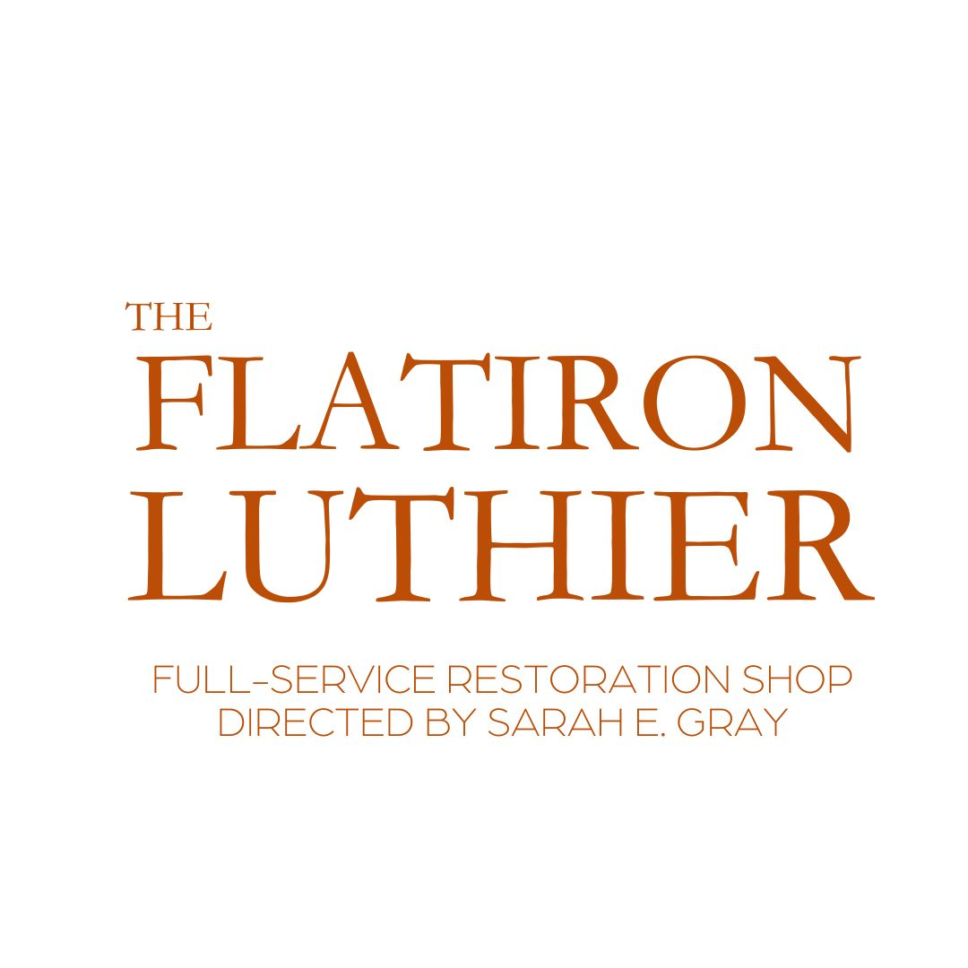  Creative Director/President Sarah Kluge  of Sarah E Gray Restoration, LLC | Now hiring for position:  Featured luthier  402.889.3515. Info@sarahgrayrestoration.com  1722 Saint Mary's Ave Suite #120 Omaha NE 68102  NE is an at will state but this position is ideally a 4+ year commitment. Inquire for extenuating circumstances.
ㅡ  The Job | The Flatiron Luthier is an incubator for luthiers to master their craft and have a better foundation to move on to run their own private shops or stay and enjoy the career advancement and flexibility The Flatiron Luthier Restoration offers. Which includes but is not limited to: paid ongoing career development and training opportunities, travel, competitive wage, profit sharing bonuses and annual living expense wage increases.  Ideally, we need a foreman or higher ranked journeyman with at least 3-5 years post graduate experience. This implies 6-10 or more years experience or tool skill equivalent. This position is geared for those who seek the experience of a storefront startup without shouldering all the risk. This position features continued education and training in restoration, tonal and ergonomic adjustments, business management, administration, marketing, and entrepreneurial ethics. Also time for making and a little flexibility in hours in the shop. This concept development shop is directed by Sarah E Gray Restoration, LLC who has served on the board of the VSA and isan active member and shop owner for over a decade. 22 years of experience trained as dedicated restorer.  The shop is adjacent to our passion project and non-profit 501(c)3 the Flatiron Luthier Cooperative so it's outreach is a prominent aspect to daily work flow. This position will require a willingness to adopt the culture of this concept shop including understanding, mutual respect, fun, humble-service centered shop. This will at times be a shared work environment but it always offers an unprecedented degree of attention lavished on each instrument that comes in the door regardless of quality or player identity. We are responsible to carefully educate customers in conservation, restoration, health, instrument and player wellbeing while being conscientious with practical spending and practical use of time. This position encourages building up a personal brand of featured luthiers by rigorous support of the shop's brand. The relentless, constant, consistent pursuit of excellence within our outstanding craft. A rising tide to float all fiddles.
ㅡ  Experience | The Flatiron Luthier, Restoration/ featured luthier  MONTH 20XX - PRESENT, LOCATION [example]  -Be sure to include your references and CV  -If you are willing to spend 1-2 hours a week on social media  -Be sure to include if you can play one or more instruments of the violin family or bass with proficiency  -If you have training in arts or photography  -If you have won any awards  -If you've attended Oberlin or Secrets of workshops or are a VSA member
-What your specialty areas are and what you'd like to focus on learning/mastering to continue to round out your career

-1-2 week bench test is part of interview process
ㅡ  About Omaha | Omaha is really an interesting place when it comes to start-ups. Entrepreneurship is relatively supported by the state and many national organizations get their start in Omaha. It boasts all the same value proposition for experiences and quality of life as its surrounding larger cities including varieties of foody-food, farmers markets, activities and music/cultural/arts events but it is small enough to only take 30 min to get anywhere. It offers very affordable living conditions, excellent schools and is one of the nation's few hold-outs with a strong emphasis on arts and music including orchestra in public schools. The shop is well appointed and in a very niche area of Omaha’s Historic Flatiron Building in what could be the theater or arts and cultures district near downtown Omaha and the old market. Omaha boasts an interesting underground music scene and constant concerts. This shop has a wonderful relationship with other shops in the area and we often team up as a collective for events or initiatives. Being central in the US it is easy and affordable to get to other areas of interest that possess mountains/oceans or amenities. Within the city there are rivers, lakes, camping, cycling, indoor rock gyms, cf, martial arts, 3 orchestras, youth orchestras, 5 nearby colleges with music programs, and the Omaha Conservatory of Music plus several other schools of music and many, many private teachers. UNL and USD boast thriving music programs and UNO is pouring resources into their programs in music as well. 1 hr flights to Chicago and Denver and Eppley is an international airport. We rely on national accounts. You will need a car. Winter can be rough and dry. Summer will be hot and humid. Those sorts of critical mass fluctuations are part of what keeps us in business, though!

